**Role B : Interrail**

To begin, I present Interrail to you. It is a ticket for the train which allows to you to travel all over Europe.  We planned in function of the Inter-Rail Pass that we buy. There are several durations.

We will take the option 10 days at 301€. This option allows to take the train 10 days during the month. You will see later that we will visit only 5 countries but thanks to this option we will be able to visit other cities and as SNCF is not sure, we must predict problems on the train.

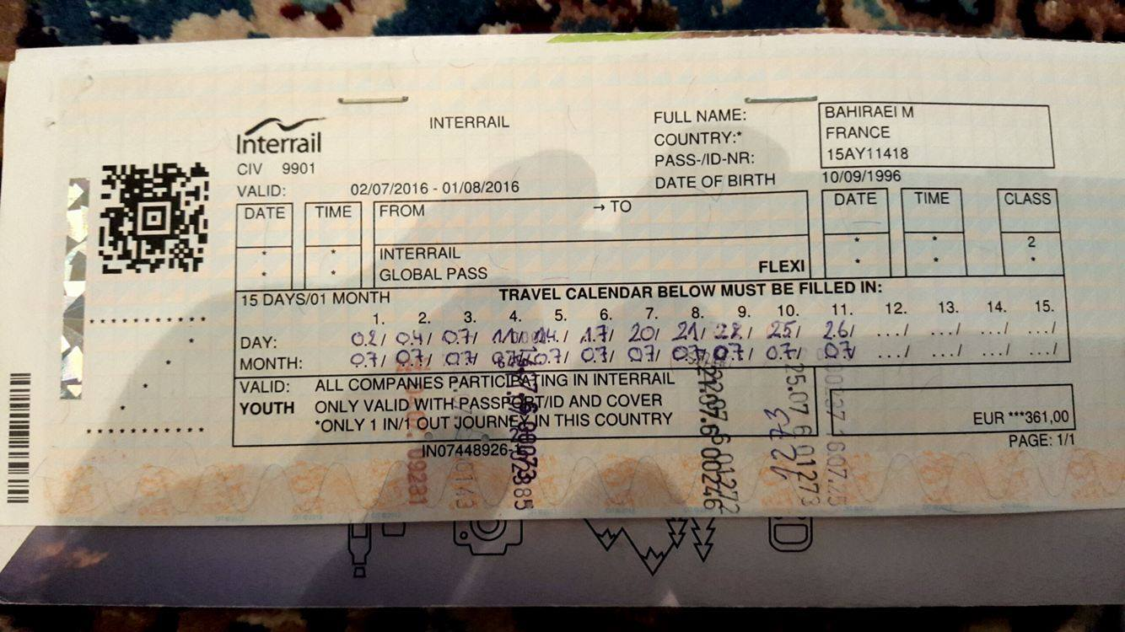

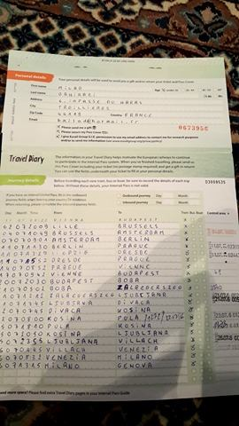

**Where do you want to go?**

The goal of this type of travel is to visit a maximum of countries. So, guys, we will travel across Europe. Like you, we will start at Rennes. Then, we will go in Amsterdam, in Berlin, in Vienna, in Turin and to finish, we will go in Madrid. In addition to this city, we will visit other cities as Milan and Rotterdam.

Thanks to these different countries we will see the different culture. I would have like visiting more countries like Croatia or Poland but in 3 weeks we don’t have the time. We will see that is the best way to travel so after do this, we can start again next year with different destinations.

**How long do you plan to stay?**

We will begin our holiday on Saturday 10 June and we will be back in Rennes on Saturday 01 July. So, our travel will last 3 weeks as agreed. In order to make the most of each country, we will stay 4 days in the country that we will traverse. This 4 days allows us to move in other cities in the countries. So, I think that 4 days is the best solution to spend good holidays but also enjoy our lives.

**Which activities have you planned?**

Contrary to you, each country has their own activities. So, I planned several activities.

To begin, in **Amsterdam**, as good tourist, we will visit the red-light district and the coffee shop. In Amsterdam, there is a particularity with the night club because it closes at 8 o’clock am. So, we will go in party. Also, we will go in Rotterdam to visit the port. For 160€, we will sleep at Stayokay Amsterdam Stadsdoelen.

Then in **Berlin**, we will visit the Alexander Platz, Checkpoint Charlie and the Brandenburg tor. Both we are football fan so, we will go in OlympiaStadium. For 96€, we will sleep at Youth hostel international.

Then in **Vienna**, there are some monuments to visit as Belvedere, Café Central and the castle of Schonbrunn. After having visit all of this, we will do a day in lake of Neusiedll. The lake is 1h30 from Vienna. For 80€, we will sleep at Myrthengasse.

Then in **Turin**, we will visit Palazzo Madama, la Mole Antonelliana and Parco del valentine. We will also visit the stadium.

We will do a day in Milan, in order to visit the city and the stadium. For 80€, we will sleep at Torino.

To go in Madrid, we will do a stop in **Nice** for a day. We will enjoy the sea and the Promenade des Anglais. For 27€, we will sleep at Hi Nice Camélia.

Next day we will go in **Madrid** where there are the Grand Via, the royal palace, the plaza Mayor and to finish, Santiago Bernabeu. For 72€, we will sleep at Concordia.

In each country, we will sleep in youth hostel. On the one hand, it is less expensive and, on the other hand, this type of accommodation allows us to share good moments with other people.

**How much would it cost?**

The price of this travel is 1100€ per person. Indeed, there is a lot of thing to take into account. 301€ for the ticket, then the price of the different accommodation and I have decided that we will spend 100€ in each country.

**Why do you recommend this type of holiday?**

Thanks to this type of holiday we can know a big part of Europe. With the interrail pass we can explore 40 000 destination.

Travel with the train is a good thing because there is not the tiredness of the car. With the train, we are free.

As we can go everywhere, each travel is different and adapted for each people.

Rennes à Amsterdam 6h30

Amsterdam à Berlin 6h30

Berlin à Vienne 11h30

Vienne à Turin 10h40

Turin à Nice 8h30

Nice à Madrid 12h20

Madrid à Paris 9h30

Paris à Rennes 2h

Départ samedi 10 juin et retour samedi 01 Juillet :

Samedi 10/08 départ gare de Rennes à 7h

10/08 Arrivé à Amsterdam à 13h30

14/08 Départ d’Amsterdam à 7h

14/08 Arrivé à Berlin à 13h30

18/08 Départ de Berlin à 7h

18/08 Arrivé à Vienne à 18h30

22/08 Départ de Vienne à 7h

22/08 Arrivé à Turin à 17h30

26/08 Départ de Turin à 7h

26/08 Arrivé à Nice à 15h30

27/08 Départ de Nice à 7h

27/08 Arrivé à Madrid à 19h30

01/07 Départ de Madrid à 7h

01/07 Arrivé à Paris à 16h30

01/07 Départ de Paris à 18h

01/07 Arrivé à Rennes à 20h30